EXPERIMENT 3_Part 3

8. Create the following table using HTML

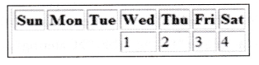

9. Create the following table using HTML

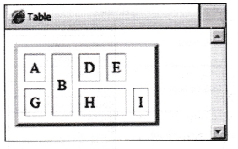

10. Write a HTML code to generate following output:-

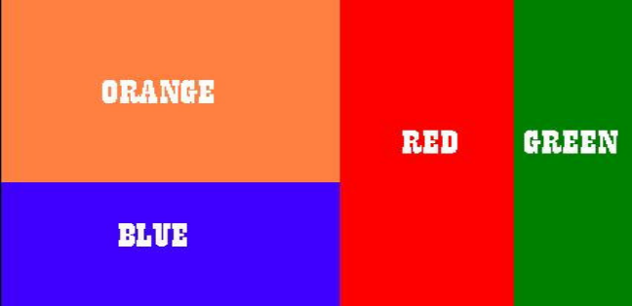

11. Write HTML code to create table having border and alternate columns and row background colors. Final output should be like this with Zebra Stripes:
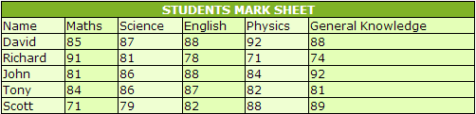

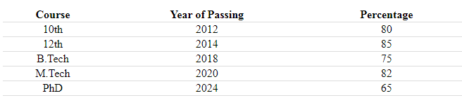
12. Write a HTML code to create the following table with horizontal divider

13. Write a HTML code with one header row, 7 data row (total 8 rows and four columns) in which first two columns background color is red, next three columns background color is blue and last two columns background color is green.

14.Write HTML code to create table having border and alternate columns and row background colors as Zebra Stripes:

